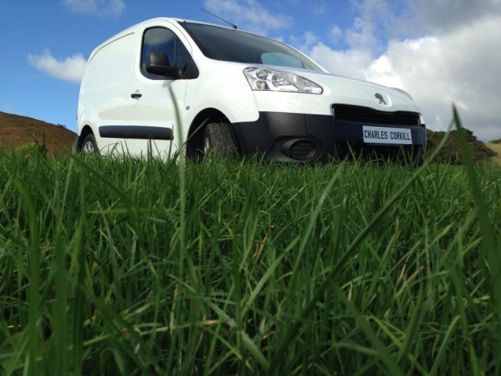
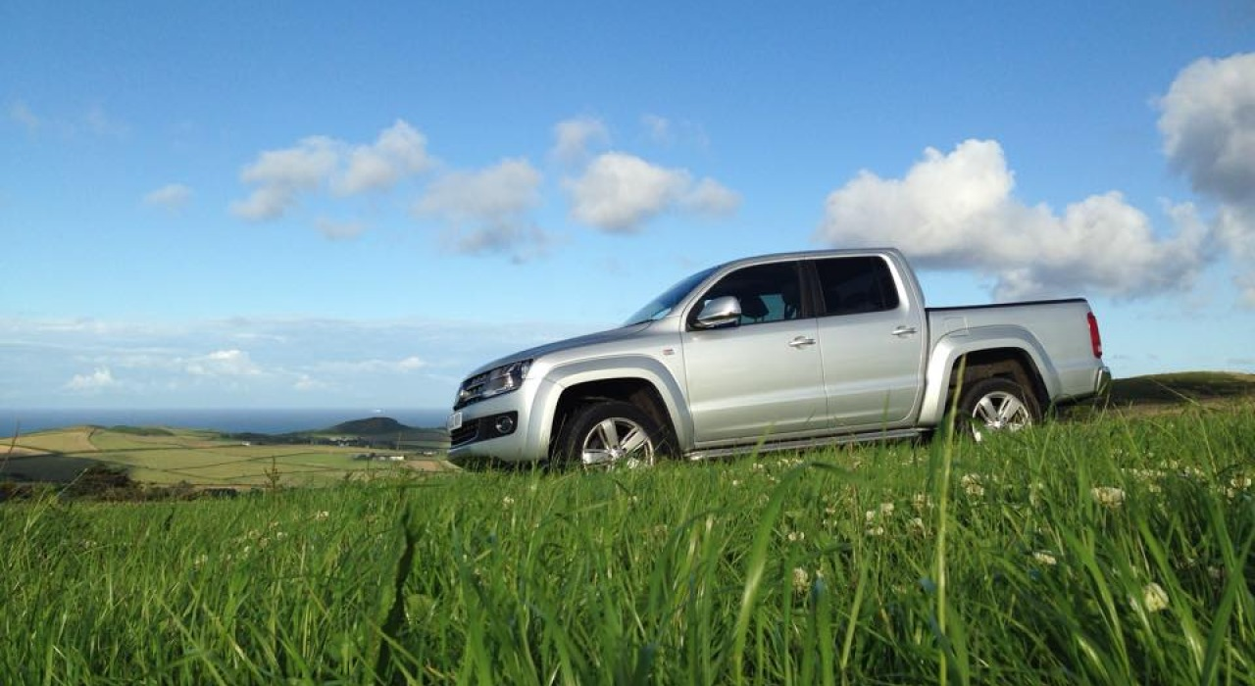

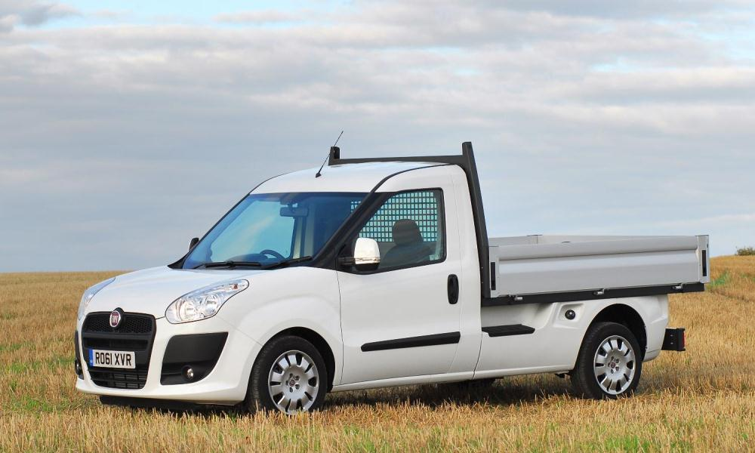
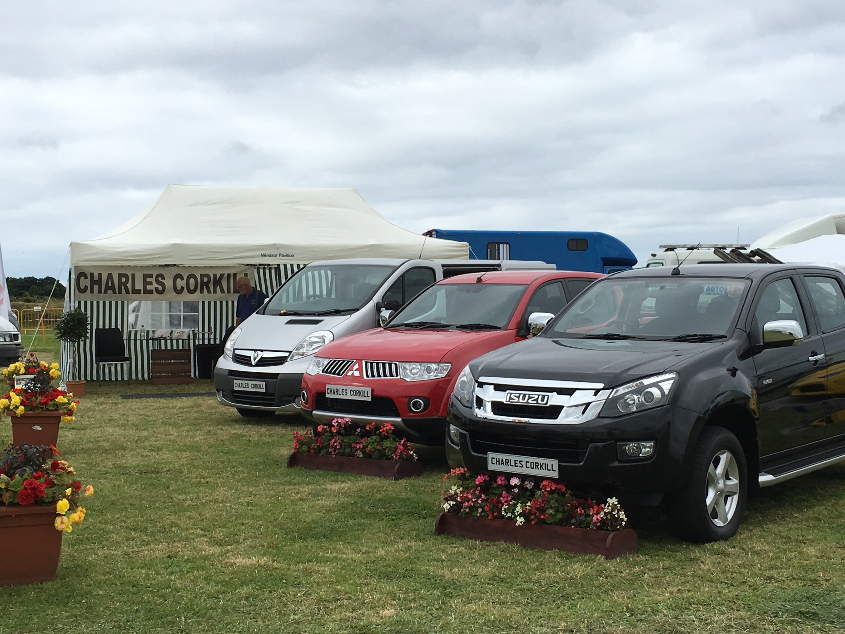
CHARLES CORKILL LTD
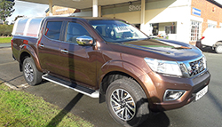
WE UNDERTAKE THE SOURCING OF QUALITY AGRICULTURAL, COMMERCIAL & PRIVATE VEHICLES TO SUIT ALL REQUIREMENTS, PLEASE CONTACT US OR CHECK OUT OUR WEBSITE -charlescorkill.com OR VISIT US AT OUR BASE AT BALLACREGGAN FARM, MAUGHOLD. PLEASE GET IN TOUCH ON 438197

